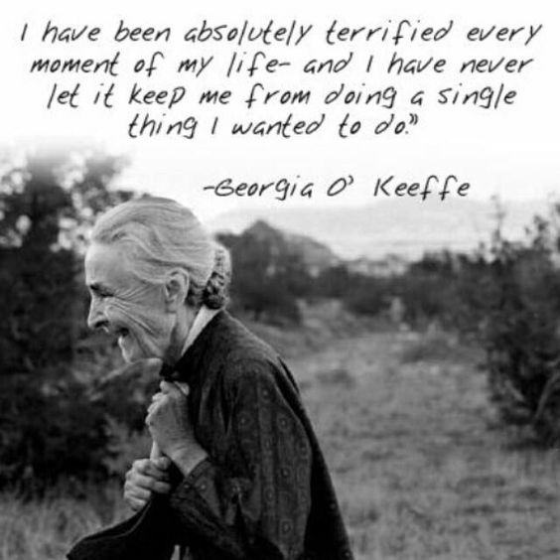

- Guest speaker: Jennifer McMahon, Mammoth Hospital, Elevate Program Coordinator

- “Stop searching for your passion” TEDx Talk:
  - https://www.youtube.com/watch?v=6MBaFL7sCb8

- Make a plan for your summer break: https://www.bestcolleges.com/blog/summer-break/
  - Plan to transfer
    - What do you need to do to be ready to submit your applications (in fall)?
      - Dial in your list
      - Visit schools
        - https://learn.imentor.org/help/transfer-shock
      - Scholarships
  - Career planning
    - Résumé
    - Research internships
  - Cerro Coso Student Services
    - https://www.cerrocoso.edu/studentservices/transfer-center
    - https://www.cerrocoso.edu/studentservices/career-center
  - Panda Planner
    - https://rocketbookhelp.zendesk.com/hc/en-us/articles/360050902913-How-Do-I-Use-the-Rocketbook-Panda-Planner-Pages-
  - My Coach app
    - https://mycoachapp.org/

- Taking care of you
  - TOML Recreation This Week newsletter: https://www.townofmammothlakes.ca.gov/CivicSend/ViewMessage/Message/169628
  - University of AZ: https://www.uagc.edu/blog/summer-study-tips-enjoy-summer-maximize-your-time
- NEXT FRIDAY! MAC Paint Pouring Art Session –May 6th
  - https://www.signupgenius.com/go/20F0844AAAB2FA3FE3-macpaint

- End of year wrap-up
  - Lois Klein: Congrats grads!

- General reminders:
  - Volunteer Log – Please remember to keep track of all brunches, Cerro Coso events, and volunteer hours and submit your log no later than the last day of the semester Friday, May 13th by 5:00pm
  - Friday, May 13th 5:00pm – Summer 2022 MLF Scholarship due - If you are taking online classes for the summer, please apply for the MLF Summer Scholarship here.
  - Monday, May 16th – Summer 2022 12-week session begins (8 & 10-week sessions begin June 6th)
  - Friday, June 10th 5:00pm – Fall 2022 MLF Scholarships due
https://www.mammothlakesfoundation.org/scholarship-applications

Group photo!

